15 apps to help you survive in Barcelona
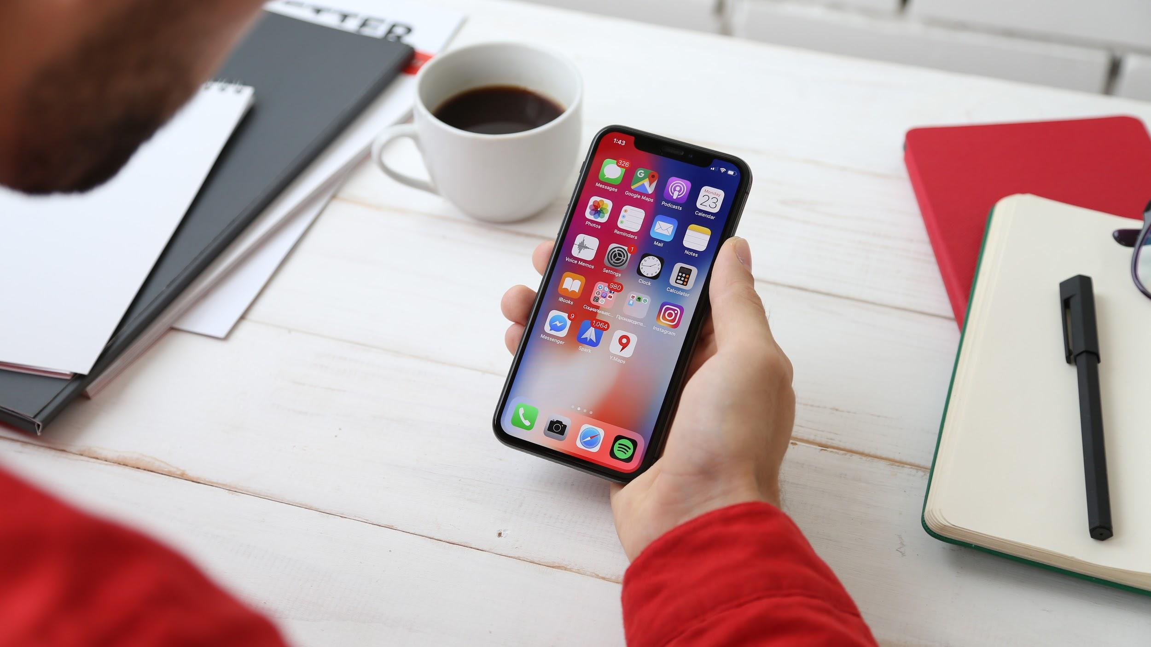

When you move to Barcelona for the first time to start your studies at ESEI, you’re going to need more than Google Maps and SpanishDict to help you survive. You’ll be relying on your smartphone a lot more than usual (time to invest in a power bank). Partly thanks to the incredibly active tech and startup scene in Barcelona, there are a ton of mobile apps that can make your life easier and help you connect with the community. We’re going to assume you’ve already heard of Glovo and Wallapop: here’s a list of 15 more apps to get you started.

Navigating business school life

MyESEI
As a student at ESEI, the MyESEI app is the best use of the precious space on your smartphone. You can use it to stay in the loop on the latest news from the school, check your grades and payments, apply to internships, request appointments and find important documents. You can also contact the ESEI staff, and access the calendar of your programme. It’s the perfect tool to help you make the most of your time at ESEI!

Getting around

eCooltra
If you really want to be immersed in Barcelona’s culture, you need to conquer your vehophobia (yes, there’s a word for ‘fear of driving’), and learn to zigzag around the city on a scooter. What better way to do it than by renting an eco-friendly electric scooter from eCooltra? You pay by the hour, and there are no pickup or dropoff stations. Just unlock the scooter with your phone and get to your classes on time!

SocialCar
Planning a weekend away? SocialCar is a cheaper and more sustainable alternative to traditional car rentals. You rent from private individuals through a secure app that handles everything from payment to insurance. All you need to do is WhatsApp the owner and figure out a time and a place to pick up the car. If you rent a spacious six-seater, you can even take a few of your ESEI buddies along!

Wikiloc
We’ve got good news for all you outdoorsy folks: there’s a platform called Wikiloc where you can find the best hiking, cycling and running trails in your area. You can choose between one-way and loop trails, filter by length, difficulty and the device you’re using the map on. The variety of activities is super impressive. Would you have thought that next to mountaineering, horseback riding and kayaking, you can also go dog sledding in Catalonia?

Connecting with the community

Lendi
Remember that drill you bought for €75 to put one hole in the kitchen wall and never used since? This shall not happen again. With the Lendi app, you can connect with your neighbours in Barcelona, have a chat with them and borrow stuff – like people would do in the olden days – so you don’t have to fill your home with expensive single-use items. Save money, save storage space and save the planet by consuming less and creating less waste.

Sharify
Sharify is a city social network where you can discover what’s happening around the city and instantly share what you’re doing. Join events posted by other users – be that a talk at ESEI, a new exhibition at the MACBA, or going for a run on the beach – and create your own. The app comes with a smart city map that shows all the events happening around you in real time.

Going out

Xceed
We all know what it feels like to end up in a random club where you can’t get into the music, the vibe doesn’t seem right to you and you can’t find your crowd. Luckily, there’s an app developed in Barcelona that’ll spare you the disappointment. Xceed helps you find clubs and parties near you that are up to your standards and in line with your taste. You can search by date, venue, style and musical genre. Plus, you can buy tickets through the app and skip the lines by flashing your smartphone at the entrance.

Whoopee App
In case clubs are not your thing and you’d rather mingle with the locals in a more intimate setting, you need to download Whoopee App. It lets you search for house parties in your area that the hosts have opened up to friendly strangers. It’s a fantastic way of meeting people when you’re new to the city, and you never know: you may find a karaoke party, a rooftop barbecue with a beerpong tournament or a cozy get-together with other ESEI students.

Match the Bar
In Barcelona, watching football matches is not optional. It’s a must. But how do you know which bar is showing a specific match? Match the Bar is an app that helps you save time when your favourite team is playing and find a bar close to you where the match is on. Make sure you gather your ESEI mates and show up on time though, because it doesn’t take long for El Clásico to fill up all the bars in the city!

Thriving on a budget

Combine
Got multiple bank accounts in different countries that come with one app each, eating up your storage space? Don’t sweat it. Combine lets you manage all your accounts in one single app, so you can keep track of your finances without having to keep filling out fifty different spreadsheets. There’s even a wallet for your cryptocurrencies!

Verse
Verse is a super handy app made in Barcelona that allows you to share expenses with roommates, split bills with friends and pitch in when you’re all going on a trip or buying a joint present. You can create groups to be able to better organize, split and track group expenses. Forget about ATMs: ain’t nobody got time to run around with cash anymore.

Transferwise
We’ve all been in a situation where we had to ask our parents for a bit of pocket money. It happens to the best of us. Whether it’s you who needs a little financial aid, or you want to send a certain amount to someone, make sure you do it through Transferwise instead of a bank. You could save up to eight times the amount that you’d have to spend on bank fees, and even pay or get paid in other currencies. It’s a no brainer, isn’t it?

Soy Comida Perfecta
As you can probably tell, this one is not a fintech service. The mission of Soy Comida Perfecta is to help fight food waste (a huge environmental problem that no one seems to talk about), and as a convenient side effect, they sell food that would otherwise go to waste for super cheap prices, up to 80% off. Don’t worry, all the products in their online store are perfectly fine to eat – sometimes their packaging is damaged, other times their expiration date is nearing, or they’re just “ugly fruits”.

Finding a place

Badi
Apartment sharing is the norm in cities like Barcelona, but sometimes it can be challenging to find the right place with the right roommates. Badi app to the rescue! Whether you need to find a room or have a spare one that you’d like to rent out, Badi is your best bet. Their Smart Recommendation System will match you with people who have similar interests and profiles, so you can avoid awkward encounters with folks you just don’t click with. And you can use it to find a place close to the ESEI campus!

Taking care of your health

TripMedic
Getting sick while you’re travelling or living in a foreign country can be a daunting experience, especially if you don’t speak the local language. With the help of TripMedic, you can find doctors who speak your language and book an appointment in just a few clicks. You wouldn’t want to miss any of your classes at ESEI because of a fever, would you?

---

Have we missed any of your favourite apps? Which ones would you add to the list?

